Mesmerizing Lunar Seas:
“HYT Moon Runner Ghost” and “HYT Moon Runner Desert”

The hyperwatch aesthetic presents a striking contrast between the engineering prowess of fluidic time and the delicate craftsmanship of miniature painting on one of watchmaking’s most fantastical complications – the Moon Phase.
Each model comes in a limited edition of only 15 pieces..
On full-moon nights, as the silver disk rises majestically into the dark sky, they're easy to spot with the naked eye. The lunar seas. That is what early astronomers imagined them to be and the name caught on for these vast liquid expanses covering almost a third of the Moon’s visible surface. Science may have revealed them to be rocky plains of basalt, but our imagination knows better.
13 of them can be observed from the Earth’s surface, the most famous being the Sea of Tranquility, where the first astronauts landed in July 1969. Less well known is the fact that this figure also includes one ocean: lying at the western edge of the near side of the Moon, the Ocean of Storms owes its name to the superstition that the last quarter of the Moon is associated with rough weather. It is also by far the largest “sea” on Earth’s satellite.
Today, Neuchâtel-based HYT proudly unveils a singular take on the lunar seas with two new models, evocatively named “Ghost” and “Desert”.
Nestled at the heart of a carbon fiber and titanium case for the former, or in one made from black DLC-treated titanium for the latter, the moon phase appears under a new guise in the Moon Runner collection. The approach is singular: HYT revisits the classic complication through a contemporary lens, catapulting it through time with its tech aesthetic and capturing the orb’s poetry in miniature hand-painting. Note how the delicate little crater on the surface catches the eye and arouses curiosity.
Around the Moon Runner's moon, two titanium indicator discs for the days and months, respectively. The minute hand is subtly integrated beneath these two discs, so that only the triangular tip is visible. It glows in white Super-LumiNova®, making the watch eminently legible. Both the month and day indicator discs are engraved and enhanced with Super-LumiNova® as well. The retrograde hours, rendered with HYT’s hallmark meca-fluidic mechanism, pass under a domed crystal glass with an anti-reflective coating.
To create the delicate miniature painting, HYT calls on a master craftsman from MD'Art, an expert in the field. The idea is to give free rein to the artist's hand, inspiration and talent. In a process that will require a day’s work, he will paint a half-sphere measuring 11.90 mm in diameter, in the dark, with the piece lit from every angle by UV lamps. This way, every detail, once night has fallen, will faithfully represent what the human eye would observe during a solar eclipse or in twilight. These two moon facets, in fact, reveal two different patinas.
To ensure these two lunar faces have the necessary luminescence, each crater has a base of white paint which is then coated with Super-LumiNova®. Then, for Moon Runner Desert, the artist, still working in the dark under UV light, will apply beige pigments to achieve the granular structure of a sandblasted effect hinting at the myriad details of the lunar seas – a step requiring painstaking patience, dexterity and precision. On Moon Runner Ghost, the aesthetic is sleeker, more minimalist, reflecting a different face and perspective in the twilight.
The striking contrasts revealed by each of the two special editions also come through in the bi-material strap: rubber and black Alcantara for the “Ghost” version; on the Desert version, sandblasted beige details accentuate the watch's minimalist vibe.

About HYT
Founded in 2012, the independent Swiss watch brand HYT introduced an original and exclusive approach to measuring time developed entirely in-house: HYT’s patented mechanical-fluidic technology combines a mechanical movement with a retrograde time indication in which a fluorescent fluid circulates through a system of capillary tubes.
HYT was born just over a decade ago from the dream of introducing fluid mechanics into the time display of a mechanical watch. To this day, the still young independent Swiss watchmaker has remained true to a highly personal philosophy of the art of horology, guided by the ambition to delve deep down to the very origins of time measurement dating several thousand years.
This led HYT to develop an avant-garde technology that uses the energy generated by the watch movement to animate fluid mechanics – fluidic time.
The solution to this complex equation was found by Lucien Vouillamoz. It involves three key elements from the aerospace industry: first, a glass capillary tube measuring 0.8 mm in internal diameter; second, a fluidic module 10,000 times more waterproof than a watch resistant to 10 ATM; and third, a system of bellows measuring a quarter of the thickness of a human hair.
Over the past ten-plus years, HYT has been constantly improving and enhancing the reliability of both its system and its movements. 2023 marks an important milestone as HYT enters a new phase in its development and reaches maturity. HYT timepieces, produced in limited editions, are sophisticated, complex and out of the ordinary, elegantly extravagant. The course is set for uncompromising exclusiveness.
Technical specifications

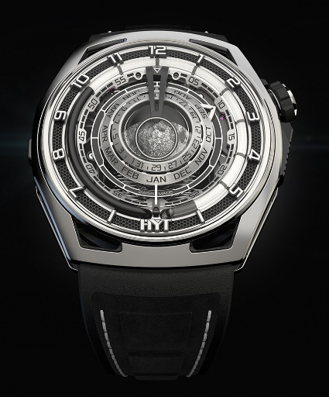 | Model  HYT Moon Runner Grey Ghost  REFERENCE: H02981-A  Limited EDITION of: 15 pieces  Suggested price: CHF 125,000 (excl. taxes)  Back engraves: HS 19  NON-CONTRACTUAL PICTURE
Case  - Titanium & Carbon  - Crown in coated black & silver titanium  - Domed sapphire crystal (box) with  anti-reflective coating  - Silver side grids with black background  Dial  - Black coated brass (58 pcs)  - 3D black-coated appliques  white luminescent numerals and  white luminous logo (SLN blocks  - Black grid with black background  - Black liquid inside borosilicate capillary tube  - Waterproof to 30 m  Movement  - Ref. : 601-MO (516 pcs)  - Type : Mechanical  - Frequency : 28,800 vib/h (4 Hz)  - Jewels : 42  - Winding : Manual  - Power reserve : 72 h  - Finishing : Finely sand-blasted and satin-finished  - Coating : Black coating |  | Functions  - Fluidic retrograde hours  - Central minutes hand  - 3D moon phase  - Day of the month  - Month  strap  - Black rubber strap  - Black microfibre embossed decoration  - White stitching  clasp  - Pin buckle  - Titanium  - Polished & sand-blasted finishes  hands  - Silver minutes hand, white SLN block  - Silver satin day of month disk, black SLN  - Silver satin month disk, black SLN  - Silver Moon white SLN & Micropainting  - All SLN in Super-Luminova®  Dimensions  - Width: 48,00 mm  - Length: 52,30 mm  - Thickness: 17,20 mm

Specifications

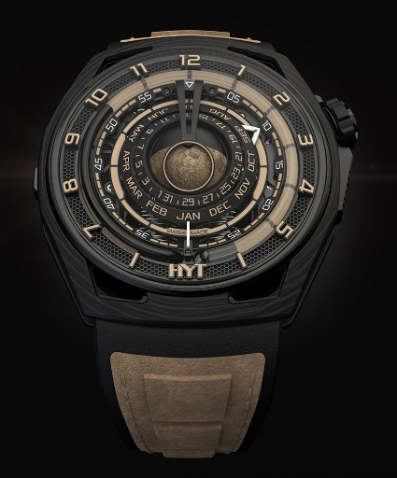 | Model  HYT Moon Runner Desert  REFERENCE: H02984-A  Limited EDITION of: 15 pieces  Suggested price: CHF 125,000 (excl. taxes)  Back engraves: HS 12  NON-CONTRACTUAL PICTURE
Case  - Black coated sand-blasted finished titanium & carbon  - Crown in titanium black DLC  - Domed sapphire crystal (box) with  anti-reflective coating  - Black side grids with beige/sand background  Dial  - Black coated brass (58 pcs)  - 3D black-coated appliques  beige/sand luminescent numerals and  beige/sand luminous logo (SLN blocks  - Black grille with black background  - Black liquid inside borosilicate capillary tube  - Waterproof to 30 m  Movement  - Ref. : 601-MO (516 pcs)  - Type : Mechanical  - Frequency : 28,800 vib/h (4 Hz)  - Jewels : 42  - Winding : Manual  - Power reserve : 72 h  - Finishing : Finely sand-blasted and satin-finished  - Coating : Black coating |  | Functions  - Fluidic retrograde hours  - Central minutes hand  - Day of the moon  - 3D moon phase  - Month  strap  - Black rubber strap  - Beige/sand microfibre embossed decoration  - Beige/sand stitching  clasp  - Pin buckle  - Black-coated titanium  - Satin & sand-blasted finishes  hands  - Mat black minutes hand, white SLN block  - Mat black day of month disk, beige/sand SLN  - Mat black month disk, beige/sand SLN  - Black Moon white SLN & Micropainting  - All SLN in Super-Luminova®  Dimensions  - Width: 48,00 mm  - Length: 52,30 mm  - Thickness: 17,20 mm

